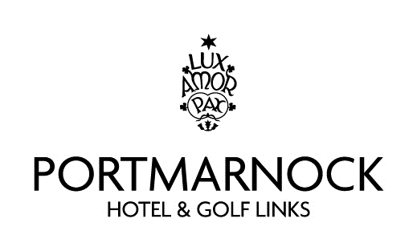

Annual Fundraising Corporate Golf Day
In aid of the Portmarnock Integrated Arch Club
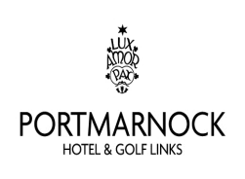
The Arch Club: Located on Strand Road, Portmarnock and founded over 20 years ago by the parents and friends of people with special needs, the Arch Club provides a social club for more than 80 members with special needs. The running cost of the club is approximately €70,000 each year, which is raised primarily through fundraising. This allows the members to partake in 2 short breaks per year giving both carers and members a much needed respite break. These breaks cost in excess of €15,000.
Our Annual Corporate Golf Day is a significant event in our fundraising calendar
Portmarnock Hotel and Golf Links is hosting this year’s Fun Golf Day on Friday the 24th May 2019
This is a wonderful opportunity for you to entertain your clients or guests.
It will be a shot gun start at 2:30pm Dinner served in the hotel at 7.30 pm This will be followed by presentation of prizes at 8.30 pm
Golf format: Four Ball team scramble. All teams should present themselves at the Clubhouse 45 mins before tee times.
Costs: €600 for team.
€100 for tee and green
Anyone wishing to make a donation or provide a prize would be most welcome.
Contacts:
Bernard Mc Gowan 0872554424 Sinead McGowan 086 340 1524
Noel Murray 086 255 5022 Andrew Nolan 087 673 8993

The Arch club is a registered charity and companies participating will receive a receipt for tax purposes.

