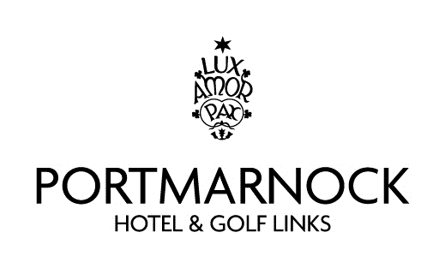

**Annual Fundraising Corporate Golf Day**

**In aid of the Portmarnock Integrated Arch Club**

After a long break from fundraising due to covid. We are delighted to invite you our loyal supporters back to our fun-day corporate golf.

This year Portmarnock Hotel and Golf Links are hosting the event

on the 7th October 2021.

We have designated tee times of 9 am to 9.50am and 10.40am to 2.30pm. This is a wonderful opportunity for you or your company to entertain clients or guests on the day.

We will have a 4-person team with 2 to count on each hole, nearest the pin on the 3rd hole and longest drive on the 4th hole.

After your golf you and your team will be served a beautiful meal in the Hotel.

There will be a presentation at 8pm in the Moyne Suite with excellent prizes

This event goes a long way towards the Clubs Annual running costs of €80k.

Thanking you all for your goodwill and support.   
  
**Sponsor a team: €600  
Sponsor a tee / green: €100**

(Anyone wishing to make a donation or provide a prize would be most welcome.)

**Contacts:**

**Bernard McGowan 0872554424 Sinead McGowan 086 340 1524  
Noel Murray 086 255 5022 Brian McGowan 0876089121**

**The Arch club is a registered charity and companies participating will receive a receipt for tax purposes.**

